**Silver Roi V. Ramos**

**First Assignment**

1. What is your name?

My name is Silver Roi Valdez Ramos.

1. Please tell us a bit more about yourself including where you're from, hobbies, interests, etc.

I am currently a 4th year BS InfoTech student at DMMMSU - MLUC, City of San Fernando, La Union. I was born on December 15, 1999, at ITRMC, City of San Fernando, La Union. I am currently living in Tanqui, City of San Fernando, La Union with my parents, Rosauro D. Ramos and Zenaida V. Ramos. I have also a younger sister and her name is Irish Danica V. Ramos. My current hobbies are watching series and anime, playing games, and watching sports. I am also interested in solving logic problems and documented crime series.

1. How much coding experience do you already have?

In my four years as a student, I tried using different languages such as C++, Javascript, and PHP. With the programming languages I tried using, I was able to develop websites and applications.

1. How did you hear about Village88 training program? What are your goals for the program?

One of my close friends introduced Village88 to me. My goal for the program is to learn new concepts about programming and to enhance my current skills to be better at programming.

1. Please include 2 or 3 pictures of yourself and a brief context of each picture. We want to get to know you better!

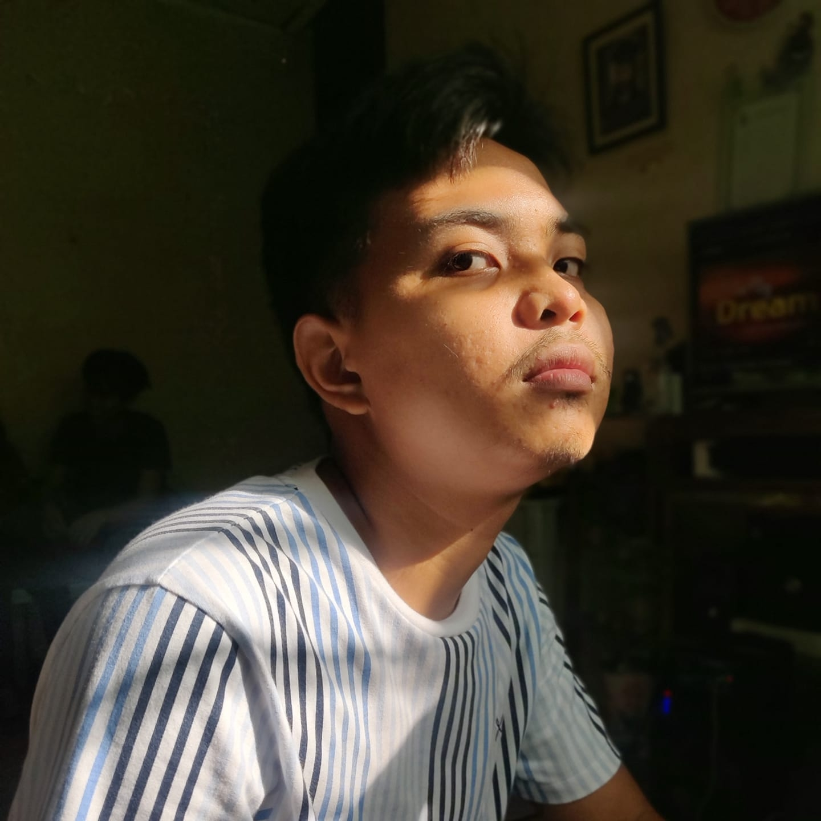

This photo was taken on my birthday. This photo was taken by one of my closest friends. I am a friendly person.

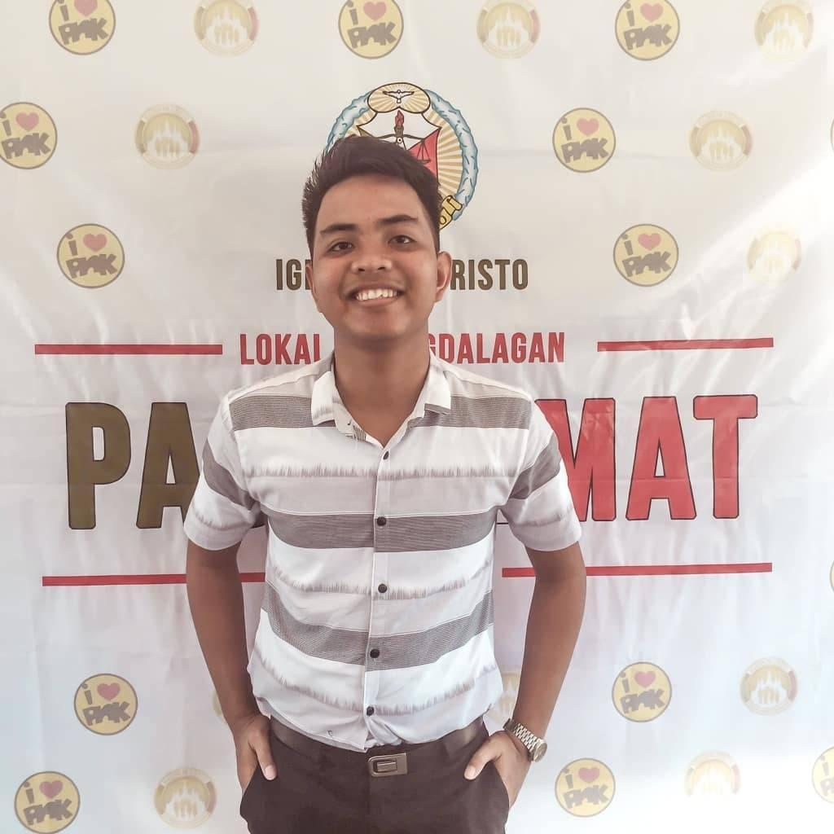

This photo was taken on Thanksgiving Day. I am currently an active member of our church.